Space

Among the essential elements of design, space is one of the most fundamental ones, as it serves as the basis for all other design elements to be applied. Here, we will explore the significance of space in interior design, focusing on its types, characteristics, as well as practical techniques for its effective utilisation.

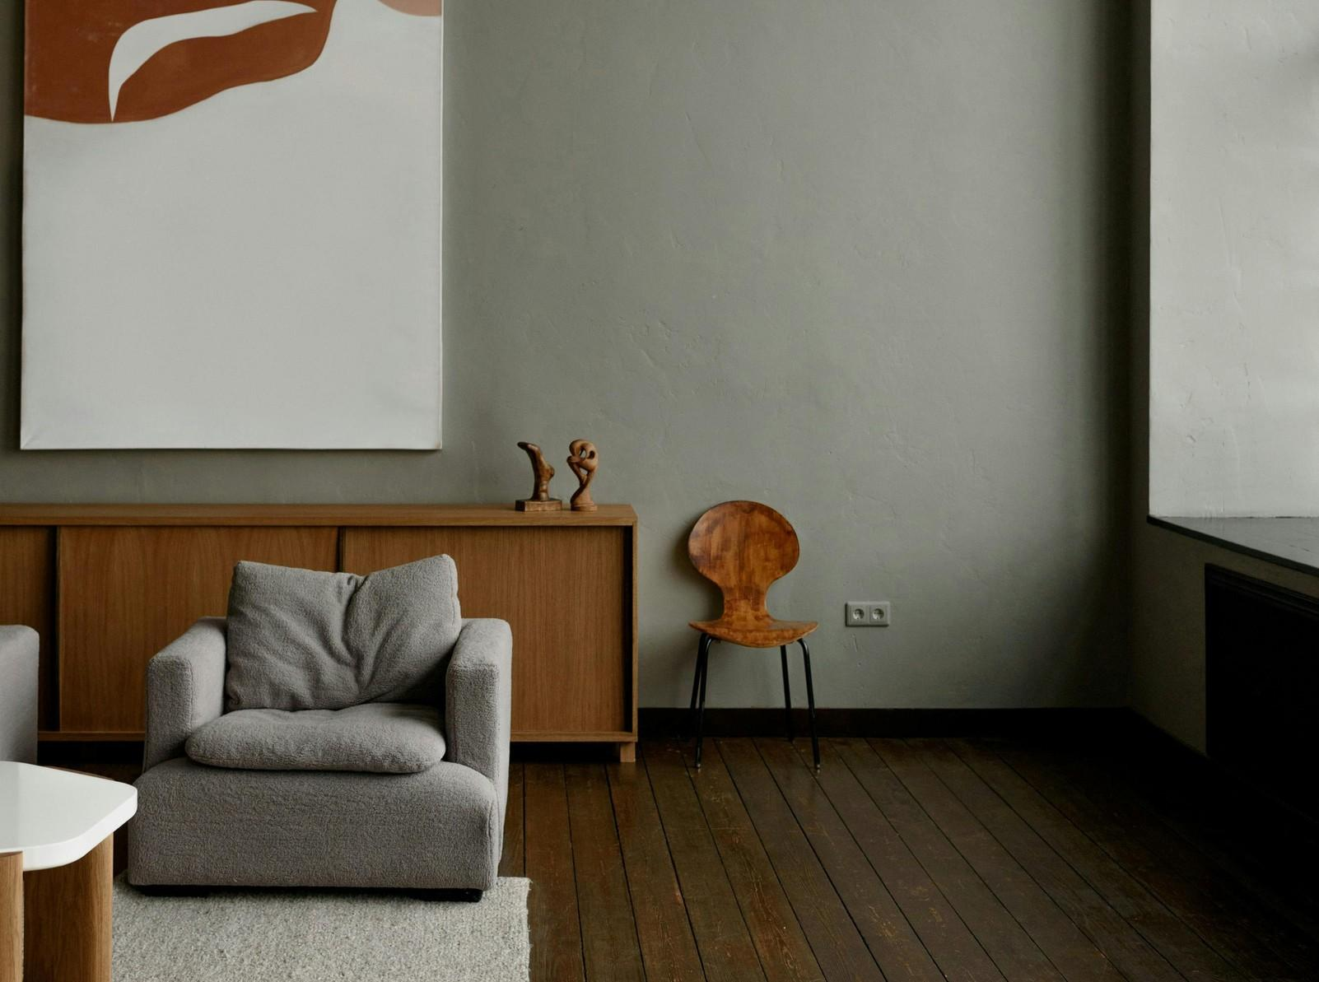

Fig. 1. Pexels (2024), Left: Positive Space, right: Negative space

# Understanding Space in Interior Design

One way of translating Space in interior design can be to focus on the area within a room that is available for furniture, décor, and movement. It can be categorised into two main types: positive space and negative space.

* **Positive Space:** The area occupied by objects like furniture, artwork, and other physical elements within a room.
* **Negative Space:** The empty area around objects, such as alcoves, nooks, or empty areas that provide balance and breathability in a room's design.

A well-designed interior balances positive and negative space, and avoids clutter, while ensuring the room feels complete and inviting.

# Types of Space

In addition to the basic categories of positive and negative space, interior designers work with specific types of space, each serving a unique purpose.

1. **Functional Spaces:** These are the areas designed for specific activities, such as cooking in the kitchen, working in the home office, or sleeping in the bedroom. Functional spaces must be carefully planned to ensure they meet the needs of their users.
2. **Circulation Spaces:** These are the areas that allow movement within a room, such as hallways, pathways between furniture, and entryways. Circulation spaces should be free of obstructions and designed to facilitate easy movement.
3. **Negative Spaces (Alcoves, Nooks, etc.):** These spaces are often overlooked but can add depth and interest to a room. Negative spaces include alcoves, corners, and nooks that can be used creatively for storage, display, or seating.

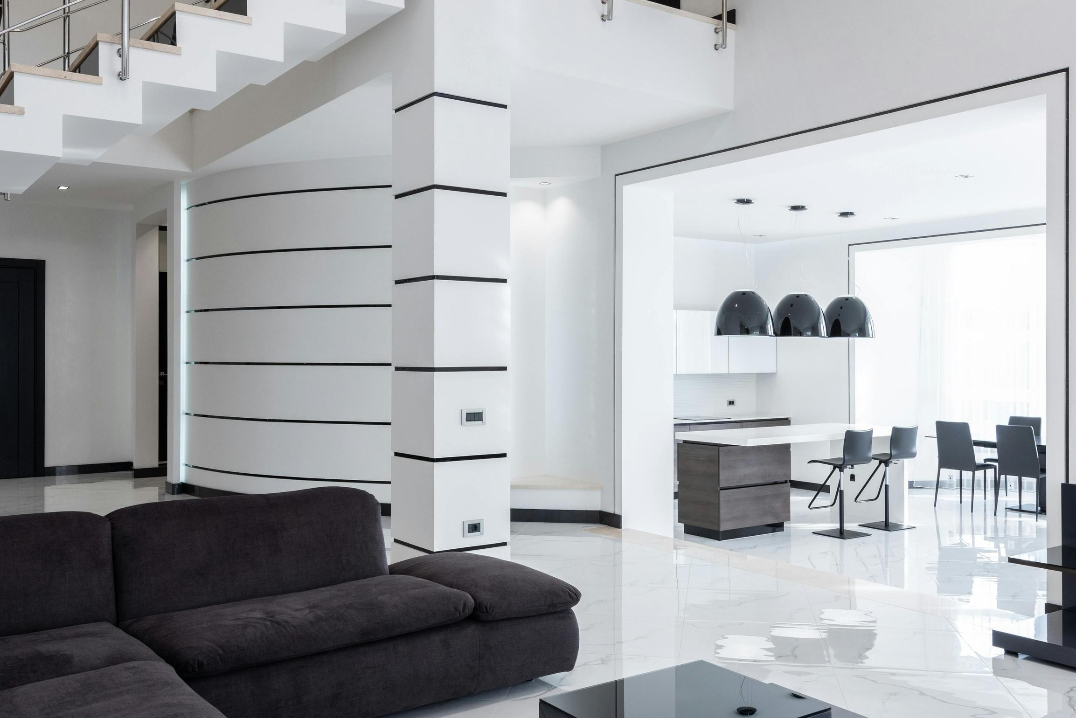

Fig. 2. Pexels (n.d.), Functional Space, Circulation Space & Negative Space

# Characteristics of Space

Space in interior design is characterised by several important design principles and elements:

* **Scale and Proportion:** The size of the space in relation to its contents and the overall room. Proper scale ensures that furniture and decor are appropriately sized for the room.
* **Light and Shadow:** How natural and artificial light interacts with the space, creating depth, dimension, and mood.
* **Texture and Material:** The surfaces within a space, such as walls, floors, and furniture, that contribute to the room's overall feel.
* **Colour and Contrast:** The use of colour to define and enhance the space, as well as the contrast between different elements to create visual interest.

# The Role of Ergonomics and Anthropometrics in a Space

Understanding the relationship between **ergonomics** and **anthropometrics** is essential for creating spaces that are not only visually appealing, but are also functional and comfortable. **Ergonomics** focuses on designing environments that enhance the user’s comfort and efficiency, while **anthropometrics** studies the measurements and proportions of the human body. By applying these principles we can ensure that furniture, circulation spaces, and functional areas meet the physical needs of the occupants/users, promoting ease of movement and reducing bodily strain in everyday activities (eg. washing dishes in a short sink etc.). Proper consideration of ergonomics and anthropometrics allows for better space planning, making interiors more accessible and user-friendly.

# Techniques for Effective Space utilisation

The following are some techniques which can help create a harmonious and balanced space. Please keep in mind that these are just guides, as each space will have unique characteristics and requirements, depending on the project brief.

* **Zoning:** Divide space into different functional areas, using rugs, furniture arrangements, or architectural features.
* **Scale and Proportion:** Select furniture and decor that are appropriately sized relative to the room and each other.
* **Layering:** Combine different design elements like furniture, textiles, and lighting to add depth and complexity.
* **Utilising Vertical Space:** Maximise space by incorporating tall bookshelves, wall-mounted storage, or vertical gardens.
* **Managing Traffic Flow:** Ensure clear, unobstructed pathways for easy movement within the room.
* **Maximising Perception of Space:** Use light colours, mirrors, and strategic lighting to enhance the sense of space.
* **Balancing Positive and Negative Space:** Leave enough negative space around objects to avoid clutter and create a cohesive design.

Space is the foundational element of interior design, influencing how a room looks, feels, and functions. By understanding the types and characteristics of space and applying effective design techniques, designers can create interiors that are both beautiful and practical. Whether in a small apartment or a spacious home, thoughtful space management is key to successful interior design.